Need the following pics:

1. A picture of the manager similar to the following…but holding a “clip board” (and not tapping his foot).



1. A picture of the manager similar to the following (from the front) – but his eye’s looking up and to the left.
2. Shot of PEOPs milling around, scratching their heads, looking up at the sky...confusion. In the middle of the screen is the manager looking disgruntled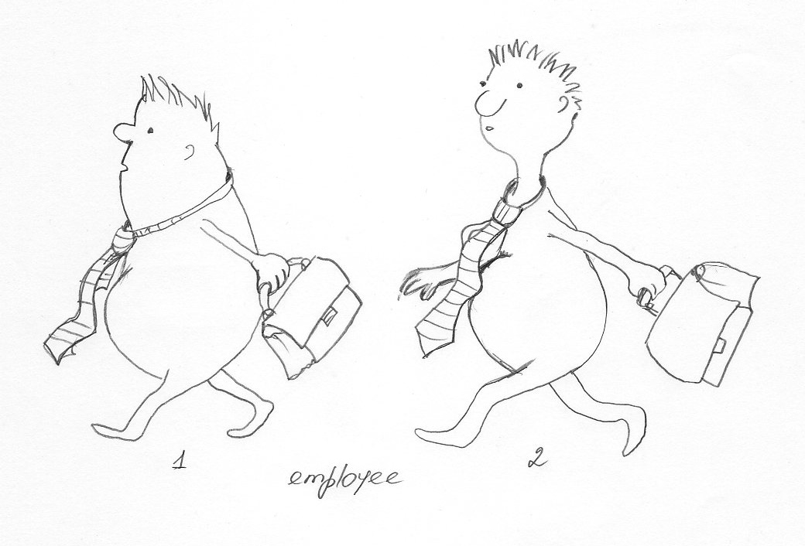
3. This is the graphic from FACEBOOK. We’re hoping to interface our software to FACEBOOK and would like to have a “peops” version of this graphic. Perhaps with the peops holding smart phones (with corny antennae) … and have the antennae “connecting” with each other. Whatever would make it looks best. I don’t have my heart set on anything really – you decide. It needs to suggest the following…but it cannot be “exactly” the same…meaning the number of people on each continent and the shape of the connections must differ.



1. A Manager looking at a “Big Screen” with alarms going off, flashing lights, dials, and statuses. It needs to represent a “Business or Operations Dashboard”.
2. A pic of a “peop” looking inquisitively at his smart phone.
3. Other Peops “Stuff” … pics that suggest:

* a “whirlwind tour”…maybe a little tornado?
* A Video…
* A Resource (books, articles, blogs, etc.)